“SPRING-REST-HANDSON”
Hands on 1
Create a Spring Web Project using Maven
1.SpringLearnApplication.java
package com.cognizant.spring_learn;
import org.slf4j.Logger;
import org.slf4j.LoggerFactory;
import org.springframework.boot.SpringApplication;
import org.springframework.boot.autoconfigure.SpringBootApplication;
@SpringBootApplication
public class SpringLearnApplication {
private static Logger LOGGER = LoggerFactory.getLogger(SpringLearnApplication.class);
public static void main(String[] args) {
LOGGER.info("STARTING: SpringLearnApplication");
SpringApplication.run(SpringLearnApplication.class, args);
LOGGER.info("STOPPING: SpringLearnApplication");
}
}
2.HelloController.java
package com.cognizant.spring_learn.controller;
import org.springframework.web.bind.annotation.RestController;
import org.springframework.web.bind.annotation.GetMapping;
@RestController
public class HelloController {
@GetMapping("/hello")
public String sayHello() {
return "Hello from Spring Boot on port 8082!";
}
}

3.application.properties
# Change server port
server.port=8082
# Logging settings
logging.level.root=INFO
logging.level.com.cognizant=DEBUG
# Enable DevTools restart
spring.devtools.restart.enabled=true
# Optional: Customize context path (if needed)
# server.servlet.context-path=/spring-learn
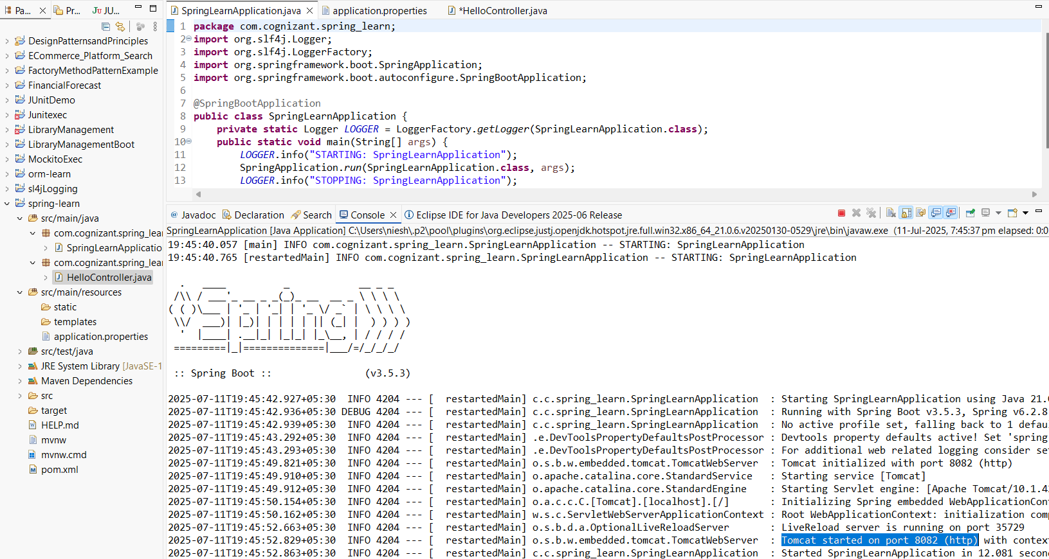
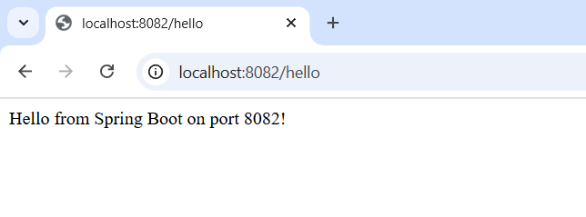
---------------------------------------------------------------------------------------------------------------------------

Hands on 2
Spring Core – Load SimpleDateFormat from Spring Configuration XML
1.SpringLearnApplication.java
package com.cognizant.spring_learn;
import java.text.ParseException;
import java.text.SimpleDateFormat;
import java.util.Date;
import org.slf4j.Logger;
import org.slf4j.LoggerFactory;
import org.springframework.boot.autoconfigure.SpringBootApplication;
import org.springframework.context.ApplicationContext;
import org.springframework.context.support.ClassPathXmlApplicationContext;
@SpringBootApplication
public class SpringLearnApplication {
private static final Logger LOGGER = LoggerFactory.getLogger(SpringLearnApplication.class);
public static void main(String[] args) {
LOGGER.info("STARTING: SpringLearnApplication");
displayDate();
LOGGER.info("STOPPING: SpringLearnApplication");
}
public static void displayDate() {
ApplicationContext context = new ClassPathXmlApplicationContext("date-format.xml");
SimpleDateFormat format = context.getBean("dateFormat", SimpleDateFormat.class);
try {
Date date = format.parse("31/12/2018");
System.out.println("Parsed Date: " + date);
} catch (ParseException e) {
System.out.println("Failed to parse date: " + e.getMessage());
}
((ClassPathXmlApplicationContext) context).close(); // good practice to close
}
}
2.date-format.xml
<?xml version="1.0" encoding="UTF-8"?>
<beans xmlns="http://www.springframework.org/schema/beans"
xmlns:xsi="http://www.w3.org/2001/XMLSchema-instance"
xsi:schemaLocation="http://www.springframework.org/schema/beans
https://www.springframework.org/schema/beans/spring-beans.xsd">
<bean id="dateFormat" class="java.text.SimpleDateFormat">
<constructor-arg value="dd/MM/yyyy" />
</bean>
</beans>
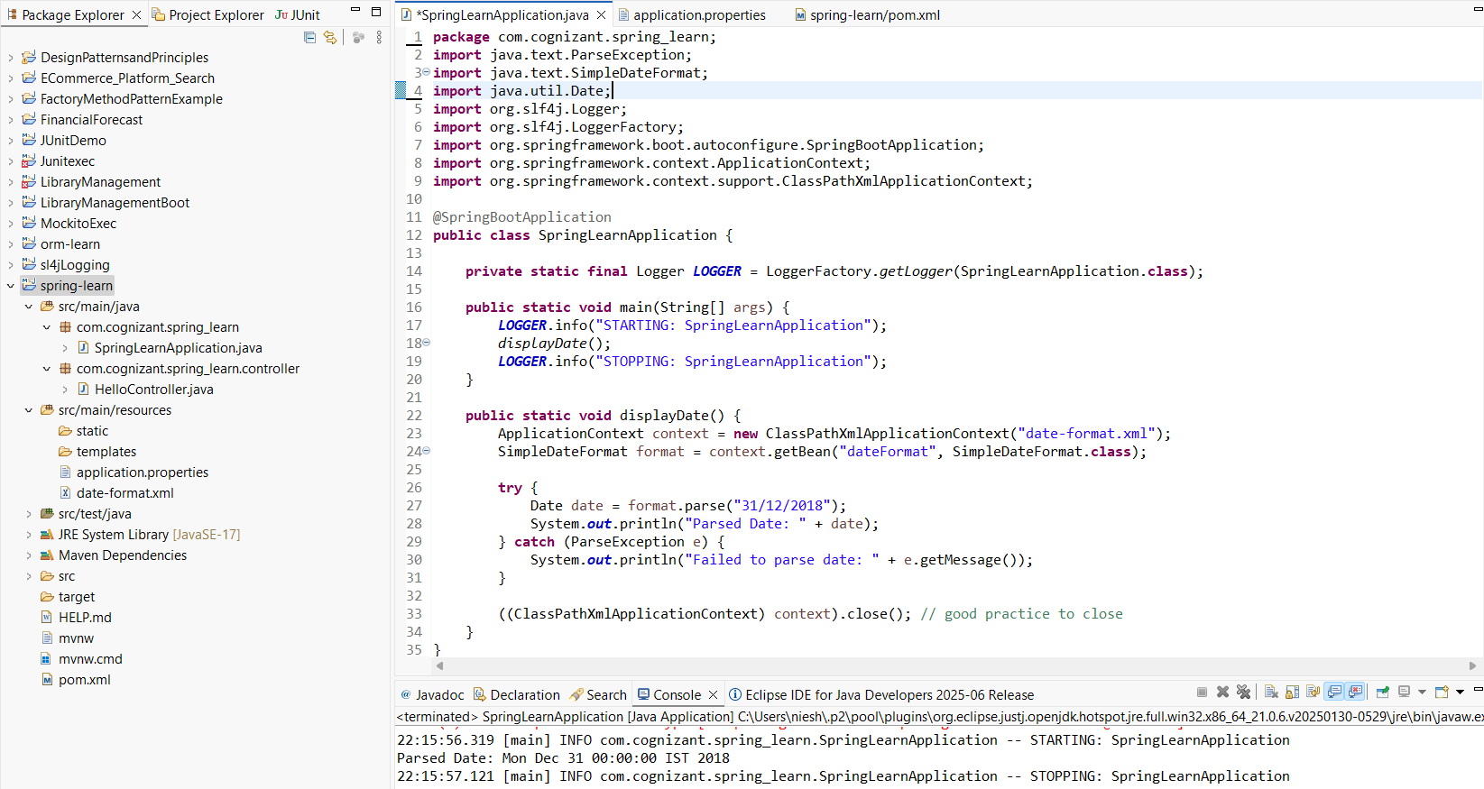

---------------------------------------------------------------------------------------------------------------------------

HandsOn 4
Spring Core – Load Country from Spring Configuration XML
1.SpringLearnApplication.java
package com.cognizant.spring_learn;
import com.cognizant.spring_learn.Country;
import org.slf4j.Logger;
import org.slf4j.LoggerFactory;
import org.springframework.boot.autoconfigure.SpringBootApplication;
import org.springframework.context.ApplicationContext;
import org.springframework.context.support.ClassPathXmlApplicationContext;
@SpringBootApplication
public class SpringLearnApplication {
private static final Logger LOGGER = LoggerFactory.getLogger(SpringLearnApplication.class);
public static void main(String[] args) {
LOGGER.info("STARTING: SpringLearnApplication");
displayCountry();
LOGGER.info("STOPPING: SpringLearnApplication");
}
public static void displayCountry() {
LOGGER.info("START");
ApplicationContext context = new ClassPathXmlApplicationContext("country.xml");
Country country = (Country) context.getBean("country", Country.class);
LOGGER.debug("Country : {}", country.toString());
((ClassPathXmlApplicationContext) context).close();
LOGGER.info("END");
}
}
2.Country.java
package com.cognizant.spring_learn;
import org.slf4j.Logger;
import org.slf4j.LoggerFactory;

public class Country {

private static final Logger LOGGER = LoggerFactory.getLogger(Country.class);

private String code;
private String name;

public Country() {
LOGGER.debug("Inside Country Constructor.");
}

public String getCode() {
LOGGER.debug("Getting code: {}", code);
return code;
}

public void setCode(String code) {
LOGGER.debug("Setting code: {}", code);
this.code = code;
}

public String getName() {
LOGGER.debug("Getting name: {}", name);
return name;
}

public void setName(String name) {
LOGGER.debug("Setting name: {}", name);
this.name = name;
}

@Override
public String toString() {
return "Country [code=" + code + ", name=" + name + "]";
}
}



